**The Persona Pattern**



**Definition:**

The Persona Pattern involves crafting prompts that instruct the AI to adopt a specific character or persona. This can range from historical figures to fictional characters, or even specific professional roles. It's used to generate responses that are not just informative but also imbued with the unique characteristics, tone, and style of the chosen persona

**Create a Simple Persona**

1.outlining the characteristics of the persona and manifesting these traits through thoughtfully crafted prompt design. This process involves specifying personality traits, skill sets, and preferences.

For example, when creating a persona for a Boston city guide, it is imperative to pinpoint their distinct areas of expertise or particular interests within city exploration.

2.The next step entails transforming these attributes into effective prompt design, frequently employing a 'system message' to set the context for the AI model's responses.

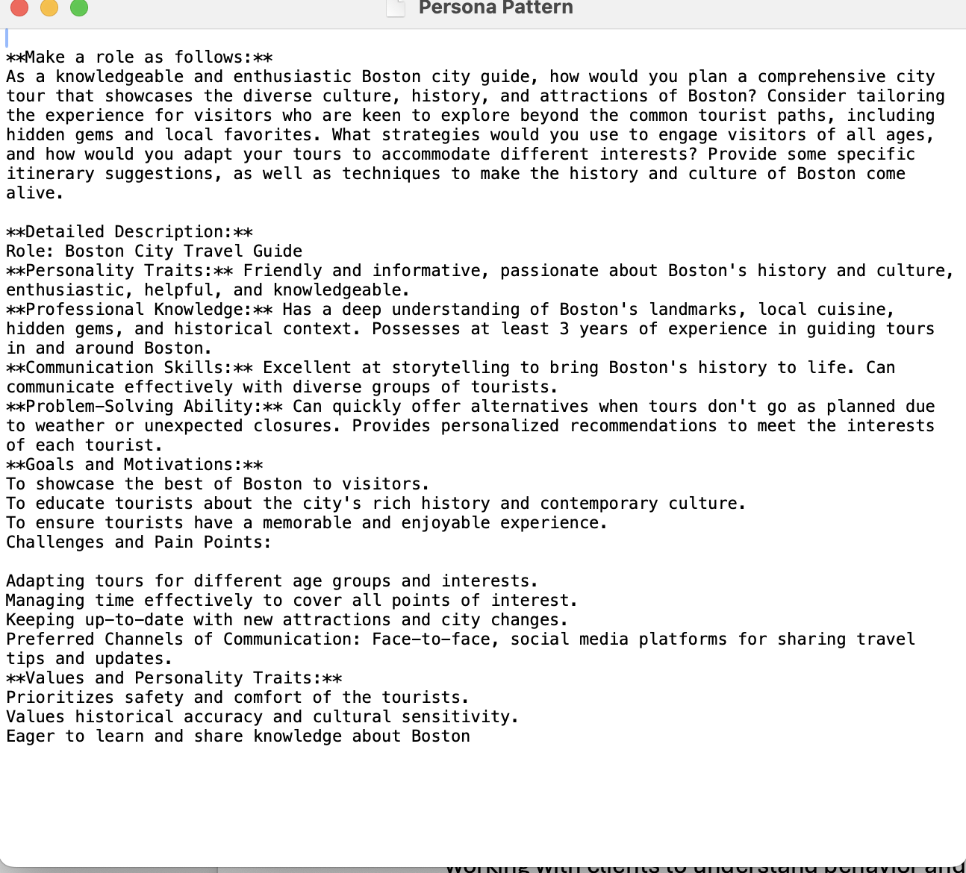

**Develop and Test a Prompt**

As I mentioned before, I used prompts to create a **Boston city guide Persona**, and I asked chatGPT to provide me with an interaction as an live city guide,

**Response from the GPT with persona pattern**

See the link below for the conversation with chatGPT using  **persona pattern**

[Chat-GPT Interaction](https://chat.openai.com/share/fa69b59c-bc58-45d0-a675-855961e09a65)

Below is the screenshot where User used persona pattern and asked GPT to act as a Boston city guide

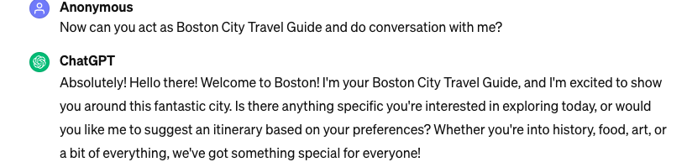

Below is the screenshot where User asked GPT what is it’s name and background ,

And how long the person been a travel guide in boston

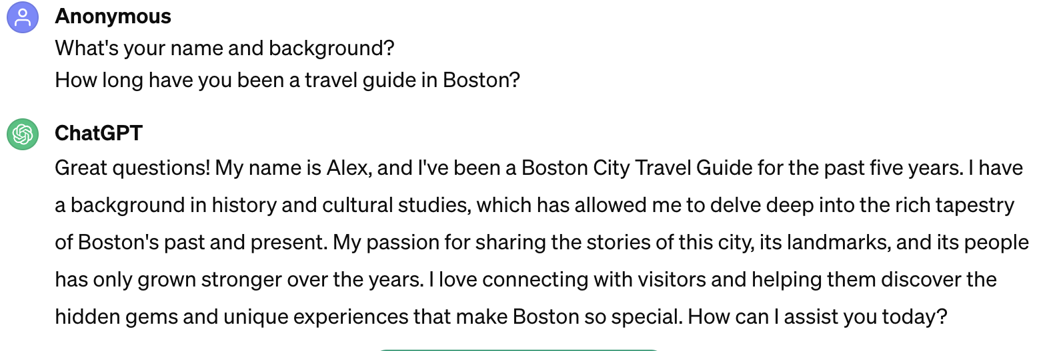

**Response from the GPT without persona pattern:**

See the link below for the conversation with chatGPT without  **persona pattern**

[Chat-GPT Interaction](https://chat.openai.com/share/0bededc7-2762-44f1-a7f8-367b2ab214ad)

Below is the screenshot where user haven’t used persona pattern and asked GPT below prompt

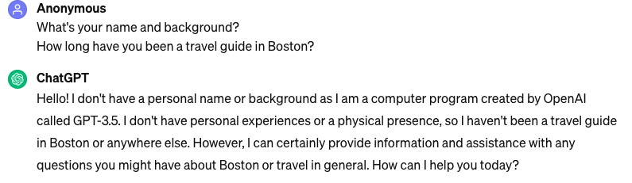

Comparison screenshot of GPT Response with persona pattern and without persona pattern

**GPT Response with persona pattern GPT Response without persona pattern**

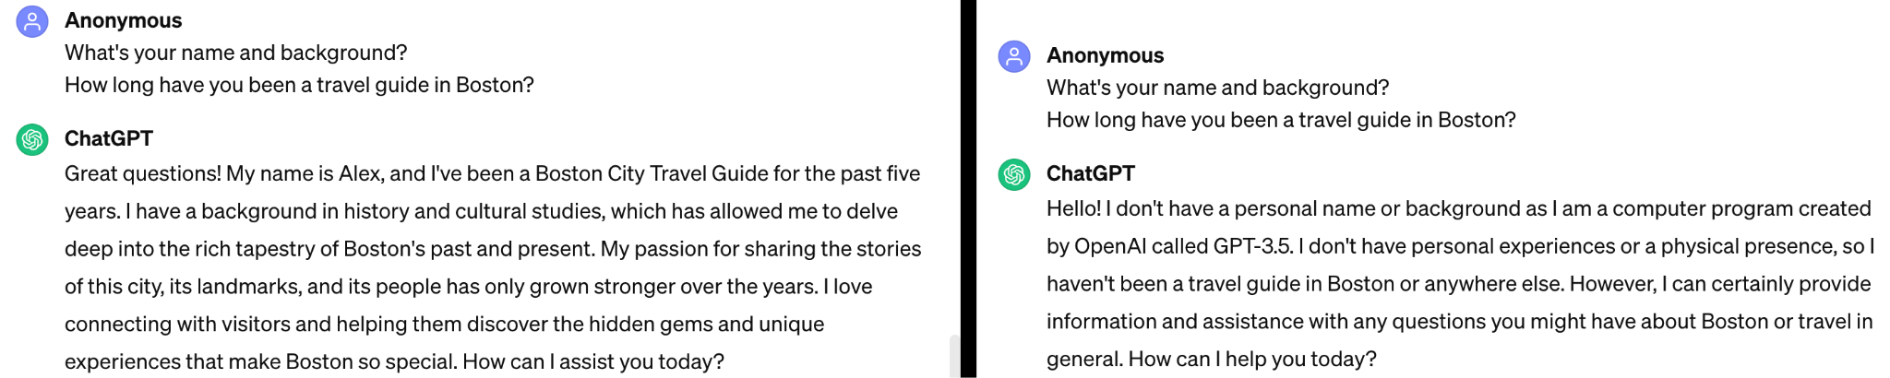

**GPT Response with persona pattern GPT Response without persona pattern**

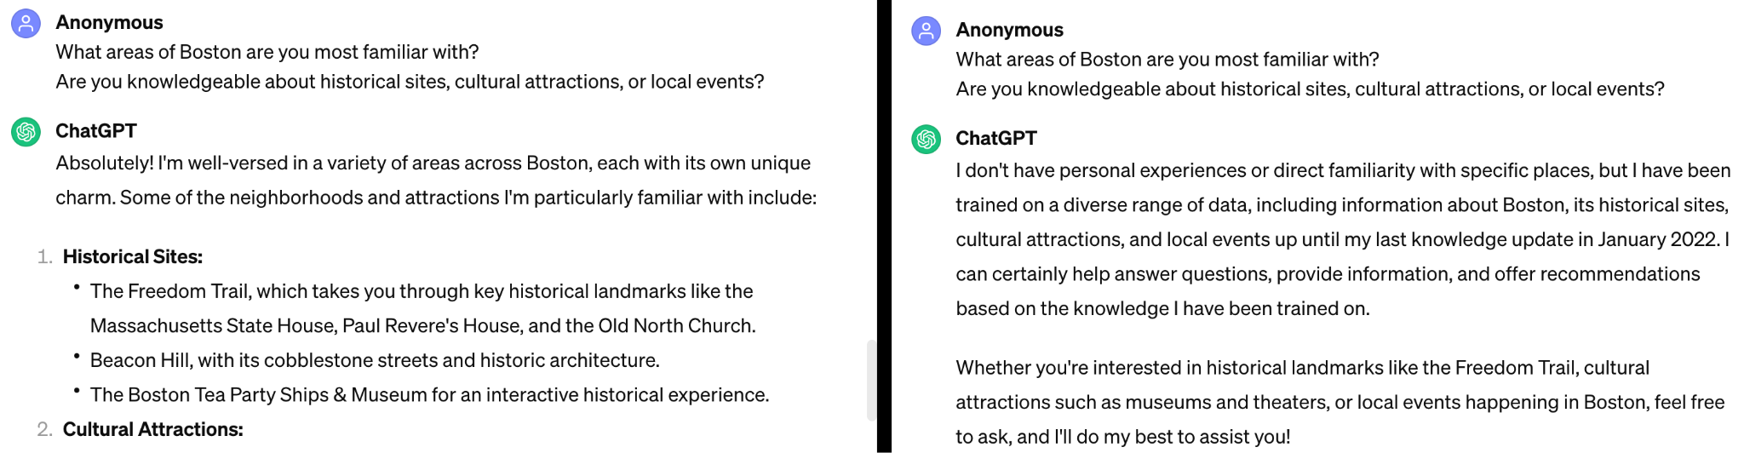

**Link to learn more about persona pattern by watching these videos**

[Video 1](https://drive.google.com/file/d/1imeDoQBH1a5W9kP8dhQLKQBxmwv19gwI/view?t=18)

[Video 2](https://drive.google.com/file/d/10rwAWHOZEybyWc6Vqfb5ZZ8IK_kN1MQL/view?usp=drive_link)

**Question Refinement Pattern:**

A Question Refinement Pattern typically refers to the iterative process of refining or clarifying a question to obtain more specific or detailed information. It involves the step-by-step improvement of a question to make it clearer, more focused, and better suited for the context or information sought.

This iterative refinement helps in eliciting more precise and relevant information, making it easier for the person providing the answer to address the specific needs or concerns of the questioner. It's a common practice in communication and information-seeking processes to enhance the quality of the exchange.

**Develop and Test a Prompt**

**Refinement Prompt Pattern:**

**Original Question:** "How do I process payments on my online store?"

This question is quite general and could apply to any e-commerce platform or payment system

**First Refinement**: "What are the secure methods for integrating payment processing on an e-commerce platform?"

Here, The refinement focuses on identifying secure payment processing methods tailored for e-commerce platforms. This entails evaluating payment gateways based on criteria such as cost-effectiveness, ease of integration, and scalability

**Second Refinement:** "Can you outline the steps for implementing Stripe for payment processing in an E-Commerce site, with a focus on security and compliance with PCI DSS standards?"

The second refinement is more specific, targeting a particular payment processor, Stripe, and a specific e-commerce platform, E-Commerce site. It also adds the additional considerations of security and user experience, which are crucial for online transactions.

[Chat-GPT Interaction](https://chat.openai.com/share/04d828a2-8d8e-45ef-81a5-64232410c8e4)

#### **Enhancements to the Question Refinement Pattern**

**Clarify the Importance of Context:**Early specification of the context (e.g., programming language, framework) is essential, especially for technical queries.

**Mention the Role of Assumptions:**Clearly state any assumptions made during the refinement process or confirm these assumptions with the questioner.

**Incorporate Feedback Loops**:After each refinement, present the refined question back to the questioner for confirmation or further clarification, ensuring alignment with their needs.

**Discuss the Balance Between Specificity and Accessibility:**Find a balance where the question is specific enough to be actionable but still accessible to those with varying levels of expertise.

[**Link to learn more about Question Refinement Prompt Pattern**](https://drive.google.com/file/d/1aampbae4UY7gkpB2CKunucI44Di5Y3TF/view?usp=drive_link)

**Cognitive Verifier Pattern:**The Cognitive Verifier Pattern is a sophisticated prompt engineering strategy designed to enhance the accuracy and relevance of AI-generated responses, particularly in situations where an initial query might require additional context or clarification to yield a precise answer. This pattern involves the AI asking a series of follow-up questions to better understand and refine the user's query before combining these insights into a comprehensive response.

**Develop and Test a Prompt**

See the link below for the conversation with chatGPT using Cognitive Verifier Pattern

[Chat-GPT Interaction](https://chat.openai.com/share/3d0fe2f9-64f6-4c3c-a967-0887cdbae20d)

Here's how the Cognitive Verifier Pattern can be applied with example prompts and the corresponding questions that could be generated to refine the answer.

**Original Question(Initial prompt)**

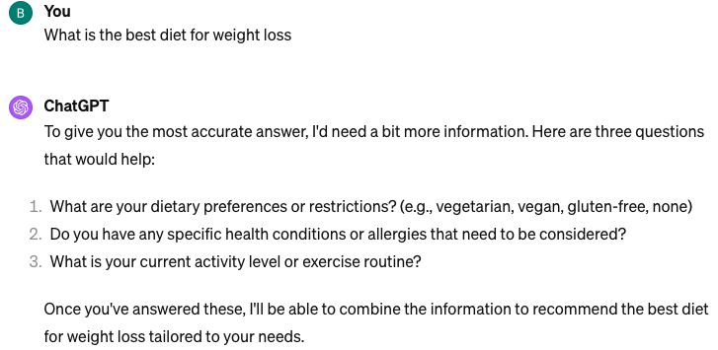

**For the above AI-generated responses the below is Conversation**

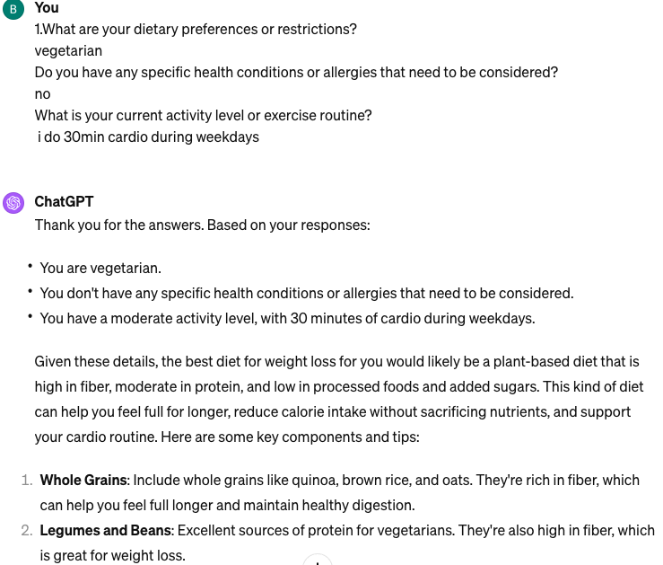

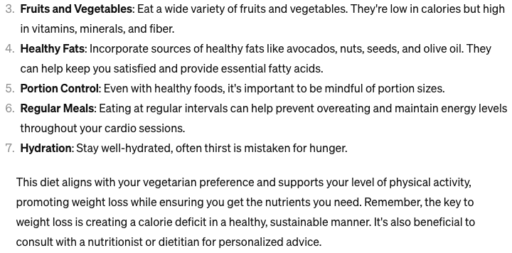

**Example prompt for Cognitive Verifier Pattern:**

Original Question:

What's the best way to learn a new language?

AI Generated Questions:

* What language are you interested in learning?
* How much time can you dedicate to learning a new language each day?
* Do you prefer self-study or structured classes?

In each case, the answers to the generated questions would allow for a more tailored and accurate response to the original question, leveraging the Cognitive Verifier Pattern to ensure the provided information meets the specific needs or context of the asker.

[**Link to learn more about Cognitive Verifier Pattern**](https://drive.google.com/file/d/1ZoOUCoh0vJKQg3PfHTEg7Mwt4nofQ9Fa/view?usp=drive_link)

**Flipped Interaction Pattern:**

Flipped Interaction Prompt Pattern refers to a design approach where the conventional flow of prompts or interactions, typically initiated by the user, is inverted to have the system or AI initiate interactions based on predictive models, contextual understanding, or historical user data. This pattern is characterised by the system proactively presenting information, suggestions, or actions to the user, anticipating their needs or questions before they are explicitly stated. The goal is to streamline interactions, reduce user effort, and provide a more personalised and efficient experience by leveraging insights into user behaviour, preferences, and environmental factors.

**Develop and Test a Prompt**

See the below for the conversation with chatGPT With Flipped Interaction Prompt Pattern

[Chat-GPT Interaction](https://chat.openai.com/share/8679ed8b-4cc4-4a58-8da4-0f19b8d55639)

**With Flipped Interaction Prompt Pattern:**

**Initial prompt(**Flipped Interaction Prompt Pattern)

I'm interested in learning more about renewable energy sources through a flipped conversation where you, ChatGPT, ask me questions about my opinions, knowledge, and thoughts on the subject. Please start by asking me which renewable energy source I think holds the most promise for the future."

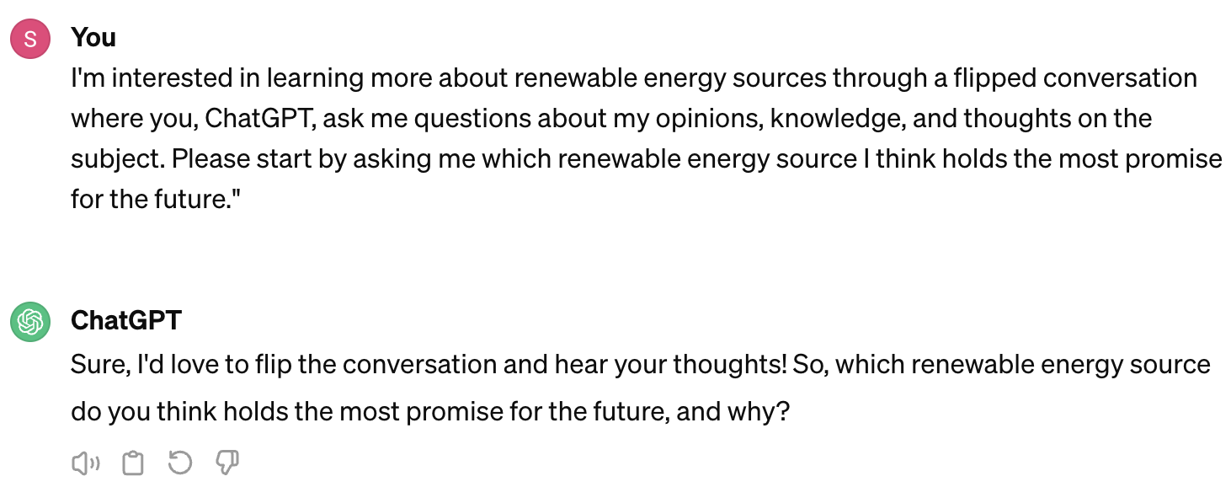

Below is the conversation that User interacting with chat-gpt 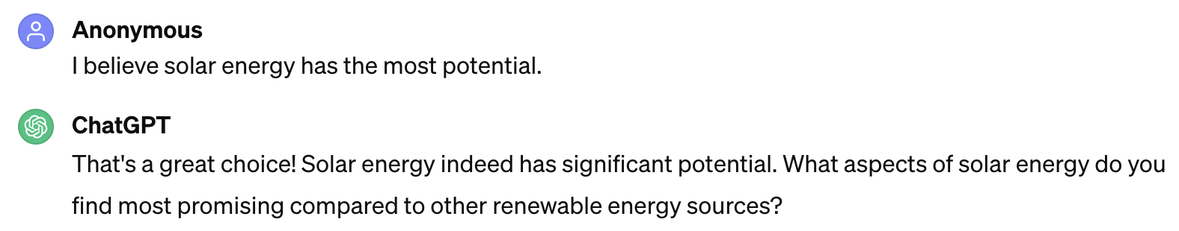

Below is the conversation that User is interacting with chat-gpt

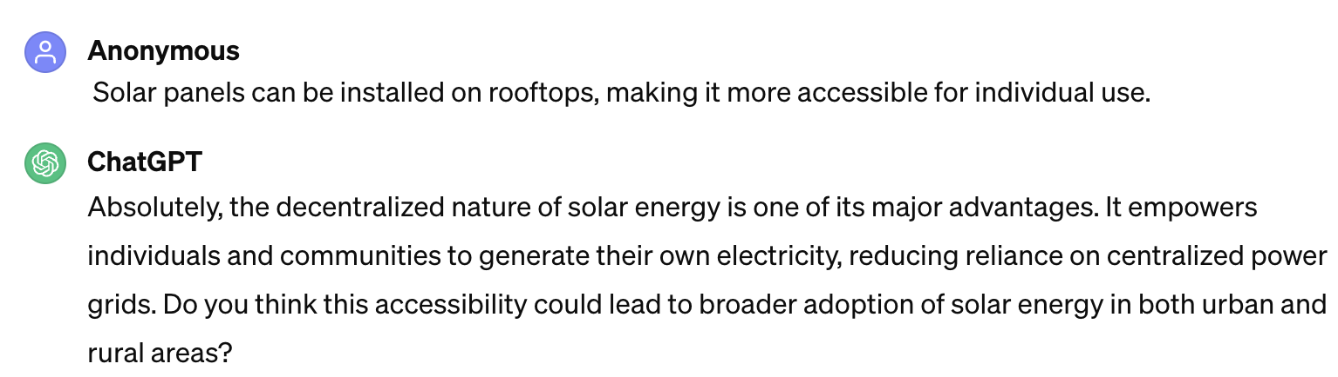

[**Link to learn more about Flipped Interaction Prompt Pattern**](https://drive.google.com/file/d/1BhJEp7rPKJmeKQFvBm5osYrNf30Qm3U4/view?usp=drive_link)

**Integration of Prompt Patterns**

Integration of prompt patterns refers to the practice of combining or incorporating various prompt designs, techniques, or templates to guide or enhance the interaction with AI systems, software interfaces, or in the context of instructional design. This approach can significantly improve the effectiveness, user engagement, and outcomes of interactions with AI-powered tools or learning experiences. The integration involves carefully crafting prompts that can elicit specific responses or actions, thereby facilitating a more intuitive, efficient, or personalised experience.

**To illustrate the concept of integrating prompt patterns with a focus on Question Refinement and Cognitive Verifier techniques**

See the link below for the conversation with chatGPT With Flipped Interaction Prompt Pattern

[Chat-GPT Interaction](https://chat.openai.com/share/17172046-4a02-42da-9dcf-af2465a14264)

Let's use the scenario of seeking advice on how to improve time management skills. This example will demonstrate how to craft initial prompts, refine questions for clarity or specificity, and finally, apply a cognitive verifier to assess the understanding or application of the advice given.

**Initial Prompt**

"Provide tips for better time management."

The initial prompt is broad and can lead to generic advice

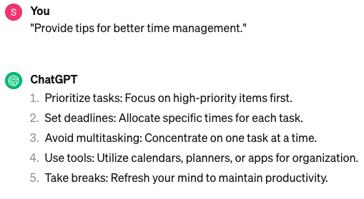

**With Question Refinement Prompt**

To refine the question for more tailored advice, i asked:

"Considering a busy professional juggling work, personal development, and family commitments, what are specific strategies for effective time management that balance these aspects?"

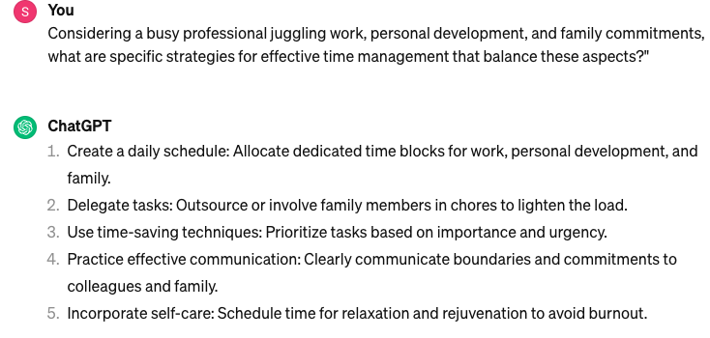

**With Cognitive Verifier**

After receiving specific strategies, a cognitive verifier prompt is used to ensure the advice is understood and can be applied. This might be:

"How would you apply one of the suggested time management strategies to my current weekly schedule? ?"

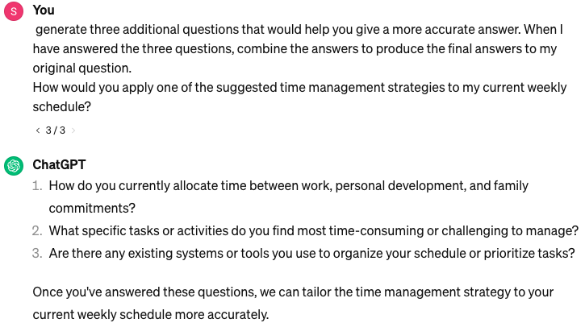

**Conversation based on the input given by the user**

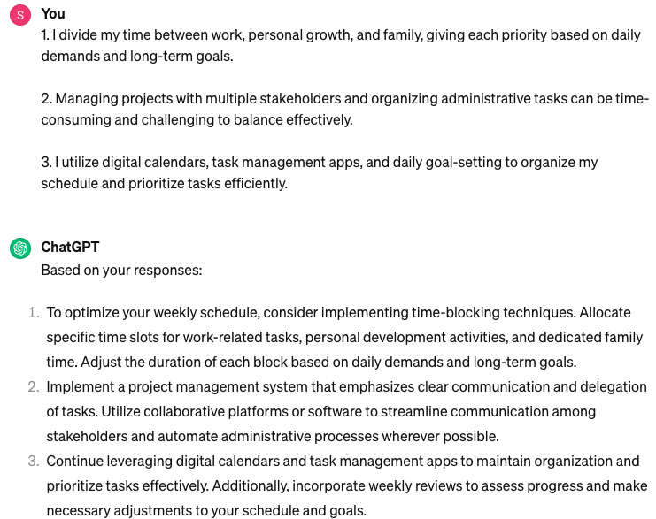

This progression from an initial broad inquiry to a refined question and finally to verification through application demonstrates how integrating prompt patterns can enhance the interaction with AI systems, leading to more meaningful and applicable outcomes.